THE ALTERNATIVE SCHOOL GROUP LTD

EVERGREEN
FOREST NURSERY

Safeguarding and Child Protection Policy

Provision Identity: Evergreen Forest Nursery is the early years provision operating at the Sapling Green Farm School and Nursery as part of The Alternative School Group Limited (TAS)

Author: | HB
Date: | 9th October 2026
To be reviewed: | July 2027
Reviewed:
Version: | 1

Note: This policy has been developed and reviewed by The Alternative School Group Limited using internal expertise, professional judgement, current statutory guidance and appropriate digital tools. Final approval and responsibility for the policy rests with The Alternative School Group Limited.

- Statement and Scope
Safeguarding is everyone's responsibility. The welfare and best interests of each child are paramount. We retain TAS's strengths-based, inclusive approach: understand what is strong within the child while maintaining professional curiosity and an attitude that 'it could happen here'. This nursery policy adapts the TAS Safeguarding & Child Protection Policy (1 September 2026) for children aged approximately 2 – 4. It applies to employees, leaders, volunteers, agency workers, students, contractors and visitors. The nursery's separate Ofsted registration is pending; it is not yet operating as a registered provision.
- Legal and Regulatory Basis
The nursery will apply the Early Years Foundation Stage statutory framework for group and school-based providers effective 1 September 2026, Children Acts 1989 and 2004, relevant childcare and safeguarding legislation, Working Together to Safeguard Children, local safeguarding partner procedures, UK GDPR/Data Protection Act 2018 and applicable Prevent, DBS and disqualification requirements. KCSIE 2026 and ISI expectations inform shared TAS school arrangements where applicable; they do not replace the nursery's EYFS and Ofsted obligations.
- Leadership and Accountability
The Nursery Manager is the nursery DSL and has authority, time and training to respond to concerns, liaise with children's social care and local safeguarding partners, manage records, referrals and staff support. A trained deputy DSL and effective cover must be confirmed before opening. The Group Safeguarding Lead (Kirsty Swierkowski) and Group Deputy (Mark Walton) provide oversight and support, but this does not displace the nursery DSL's responsibilities. TAS as proposed provider oversees suitability, staffing, policy implementation, audits and resources. Any adult may contact statutory agencies directly if a child is in immediate danger or the DSL is unavailable.
- Recognising Harm in Early Childhood
Practitioners must recognise physical, emotional and sexual abuse, neglect, exploitation and domestic abuse. Signs may include unexplained injuries, concerning explanations, changes in sleep, feeding, play, attachment, toileting, hygiene or behaviour, fearful reactions, sexualised behaviour or developmental regression. Babies and young children may communicate through behaviour rather than words. SEND, speech delay, disability, trauma or cultural difference must never be used to explain away possible harm. Record observations objectively and consider cumulative patterns.
- Reporting, Responding and Referrals
If a child is in immediate danger call 999; seek urgent medical care where needed. Otherwise inform the Nursery Manager/DSL immediately, not at the end of the session, and record on the approved secure TAS safeguarding system (Behaviour Watch if authorised for the nursery). Listen calmly; avoid leading questions, promises of secrecy or investigative questioning. Record the child's exact words, date, time, location, injury and witnesses, distinguish fact from interpretation, and note decisions and follow-up. The DSL assesses risk, considers Family Help and local thresholds, refers to children's social care/police where required, records outcomes and challenges insufficient responses. Do not wait for parental permission when this would increase risk or delay protection.

6. Concerns or Allegations about Adults
Report conduct concerns about staff, agency workers, volunteers, visitors and other adults immediately. Where the concern relates to the Nursery Manager/DSL, report directly to the TAS nominated individual/proprietor, safeguarding representative or Group Safeguarding Lead; if that route is implicated or unavailable, contact the LADO/children's social care directly. Consult the local authority designated officer (LADO) promptly where the harm threshold may be met, before conducting an internal investigation that could compromise statutory processes. Preserve records and evidence. Record and review low-level concerns separately, identify patterns and provide a whistleblowing route. Make required Ofsted notifications of allegations of harm and actions taken within the statutory timescale; check the current EYFS notification requirements and log when submitted. Consider DBS referral duties where applicable.
7. Recruitment, Suitability, Supervision and Training
Apply safer recruitment: identity, right to work, references, qualifications, employment history, enhanced DBS and barred-list checks as appropriate, disqualification and ongoing suitability declarations. Under the September 2026 EYFS changes, required enhanced criminal record checks extend to volunteers including supervised volunteers, and new employees must not commence before the required check is received. Confirm individual eligibility and roles under current law. Maintain an appropriate nursery suitability/recruitment record and any shared TAS single central record without assuming the school record alone meets nursery requirements. Induct every adult into reporting, allegations, intimate care, collection, missing-child and farm safety procedures. Provide EYFS-appropriate safeguarding training and regular staff supervision.

8. Daily Supervision, Attendance and Collection
Maintain accurate arrival/departure and attendance registers, children's expected sessions, emergency contacts and authorised collectors. Follow up unexplained absences promptly under the separate nursery Attendance Policy and escalate welfare concerns. Verify identity and authority before releasing a child; record any custody or safeguarding restrictions. Never release to an unauthorised or impaired adult; contact the DSL and, if necessary, police/social care. Apply the nursery's uncollected-child procedure and maintain supervision while contacting carers. Staff deployment must meet EYFS ratios and respond to actual risks, including toilets, outdoor learning, sleep, meals and transitions.
9. Missing Child Procedure — On Site or Farm
1. Raise the alarm immediately and tell the Nursery Manager/DSL; note the last known sighting and time.
2. Keep remaining children safely supervised and undertake an immediate headcount/register check; do not leave other children unattended.
3. Allocate staff to check pre-identified safe search zones, including rooms, toilets, exits, sheds, animal enclosures and boundaries, without entering unsafe areas.
4. If the child cannot be located immediately, or there is danger from roads, water, animals, machinery or an unknown adult, call 999 without delay; do not wait for a full search.
5. Inform parents/carers promptly, coordinate with police and TAS leadership, preserve CCTV/access logs and note search actions/times.
6. When located, assess welfare and medical needs, inform police/parents, complete incident and safeguarding records, consider required Ofsted notification, review risk assessments and debrief staff.
A missing child on an outing requires the same immediate escalation, plus contact with the venue and transport lead. No member of staff should undertake a search that leaves the remaining group inadequately supervised.
10. Farm, Animals, Outdoor Areas and Shared Premises
Before each activity staff assess boundaries, gates, fencing, animal contact, infection risk/handwashing, tools, machinery, vehicles, water, weather, terrain, public access, one-to-one work and emergency communication. Separate nursery children from school pupils, visitors and contractors unless shared access is planned and safely supervised. Maintain secure access and sign-in/out; establish who has safeguarding authority in each shared space. Do not provide registered childcare on premises where a prohibited banned dog breed is kept or present, as required by the 2026 EYFS. Review risk assessments after incidents and changes.
11. Personal Care, Health, Sleep and Nutrition
Protect dignity and privacy during nappy changing, toileting and intimate care while ensuring accountability, appropriate visibility and written individual plans where necessary. Record concerning marks using Appendix B and notify the DSL immediately; a body map is not a diagnosis. Follow separate Safer Sleep Policy for supervision, checks and suitable equipment, and the current EYFS safer-sleep requirements. Apply paediatric first aid cover, medication consent/records, accident and parent-notification procedures. Maintain allergy and dietary information, safe eating supervision, choking prevention and appropriate emergency response.
12. Online Safety, Images and Devices
Use only nursery-authorised devices/accounts to take or store children's images; follow parental permissions and safeguarding restrictions. No personal-phone photography of children. Keep phones, smartwatches and image-capable devices controlled in care areas and follow TAS device/online safety policies. Report accidental images, inappropriate sharing or online concerns immediately. Have regard to the 2026 DfE early years screen-use guidance; any screens used should be purposeful, supervised and developmentally appropriate.
13. Inclusion, Child Voice and Family Partnership
Every child has a key person. Staff use age-appropriate language, visual supports, play and communication aids so that children with SEND and communication differences can express worries. Work constructively with parents and carers, but the child's welfare overrides confidentiality expectations where lawful sharing is necessary. Recognise the importance of kinship care, looked-after children, family circumstances, domestic abuse and early help; avoid discriminatory assumptions.
14. Information Handling and Quality Assurance
Keep safeguarding files secure, access-controlled and distinct from general learning records, with clear chronology and recorded decisions. Share information lawfully and proportionately with statutory partners, including under applicable 2026 information-sharing duties. The Nursery Manager and TAS group safeguarding team audit training, suitability, concerns, absence, collection, incidents, missing-child drills, safer sleep, farm risks, referrals and outcomes. The policy is reviewed annually and after significant incidents, regulatory changes or inspection findings.
15. Links to Other Policies
Read with the nursery Attendance Policy, Safer Sleep Policy, Complaints Procedure, Staff Code of Conduct, Safer Recruitment, Whistleblowing, Intimate Care, Medicines/First Aid, Food/Allergy, Risk Assessment, Fire/Emergency, Data Protection and TAS group safeguarding procedures. Where group wording conflicts with nursery-specific EYFS duties, the nursery-specific statutory requirement prevails. The complaints procedure does not replace child protection or LADO referrals.
Source and Review Note
Adapted from TAS “Safeguarding & Child Protection Policy & Procedures”, dated 1 September 2026 (Version 25), particularly sections 1–10, 17–24 and Appendices. Updated for nursery registration pending and September 2026 EYFS. Official reference: https://www.gov.uk/government/publications/early-years-foundation-stage-framework--2. This is an operational draft requiring final leadership/local-authority verification and approval before implementation.

Appendix A — Safeguarding Reporting Pathway

- Immediate danger: call 999 and obtain medical help.
- Tell Nursery Manager/DSL immediately; if concern involves the DSL, contact TAS group/proprietor lead or LADO directly.
- Make an accurate, timely, secure safeguarding record; use Annex B for marks/injuries.
- DSL considers child’s safety, patterns, attendance, SEND, family context and local thresholds.
- DSL refers to social care/police/LADO as appropriate, follows up and records decisions.
- Group safeguarding oversight reviews outcomes; escalate unresolved risks.

Appendix B - Body Map and Injury/Mark Record
Use to document visible marks or injuries objectively. Mark exact position on FRONT and/or BACK using a numbered cross, then describe each mark below. Do not conduct an intrusive examination or photograph without approved safeguarding authority. A body map does not replace immediate safeguarding action.
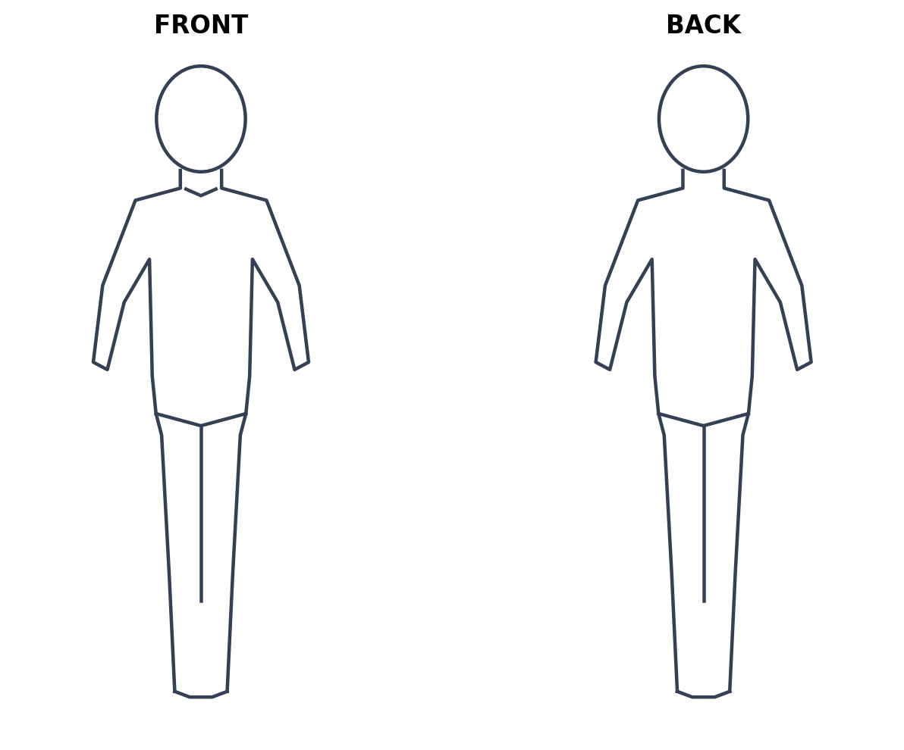Child name / ID: _______________________ Date of birth: __________________
Date and time observed: __________________ Recorded by: __________________
Location / circumstances: __________________________________________________
Mark number, site, size, colour, shape, child’s words and explanation:
1. ________________________________________________________________________
2. ________________________________________________________________________
Action taken / first aid / medical advice: ______________________________________
DSL notified (name, time): __________________ Referral / follow-up: ______________
Signature / date: ___________________________________________________________

Appendix C — Missing Child Incident Log

Child / date / expected location: __________________________________________
Last seen (time, place, person): ___________________________________________
Alarm raised and headcount time: __________________________________________
Search zones, persons and times: _________________________________________
Police call time / incident number: ________________________________________
Parent/carer contact time: _______________________________________________
Child located / welfare assessment: _______________________________________
Ofsted notification consideration and outcome: ______________________________
Debrief / risk assessment actions / owner / deadline: _________________________

